

Student Name: Zaid Jehad ,Ghazal Almidana

ID:2110012 , 2020001

University: American University of Madaba

Course: Operating Systems

Instructor: Dr. Ahmad Al-Daraiseh

Date: 23 May 2025

- Introduction

This project simulates and compares various CPU scheduling algorithms using Java. The implemented simulator enables users to configure multiple parameters such as process count, CPU/IO burst times, priorities, and arrival times. The core purpose is to analyze how different scheduling techniques affect system performance, particularly in terms of Average Waiting

Time and Turnaround Time.

The simulator includes traditional algorithms like:

- First Come First Served (FCFS)
- Shortest Job First (SJF)
- Shortest Remaining Job First (SRJF)
- Round Robin (RR)
- Priority Scheduling
- Exponential Averaging

Two additional custom algorithms were implemented:

- Random Scheduler: Picks a random process from the ready queue.

- Priority Scheduler: Assigns and schedules processes based on dynamically generated priorities.

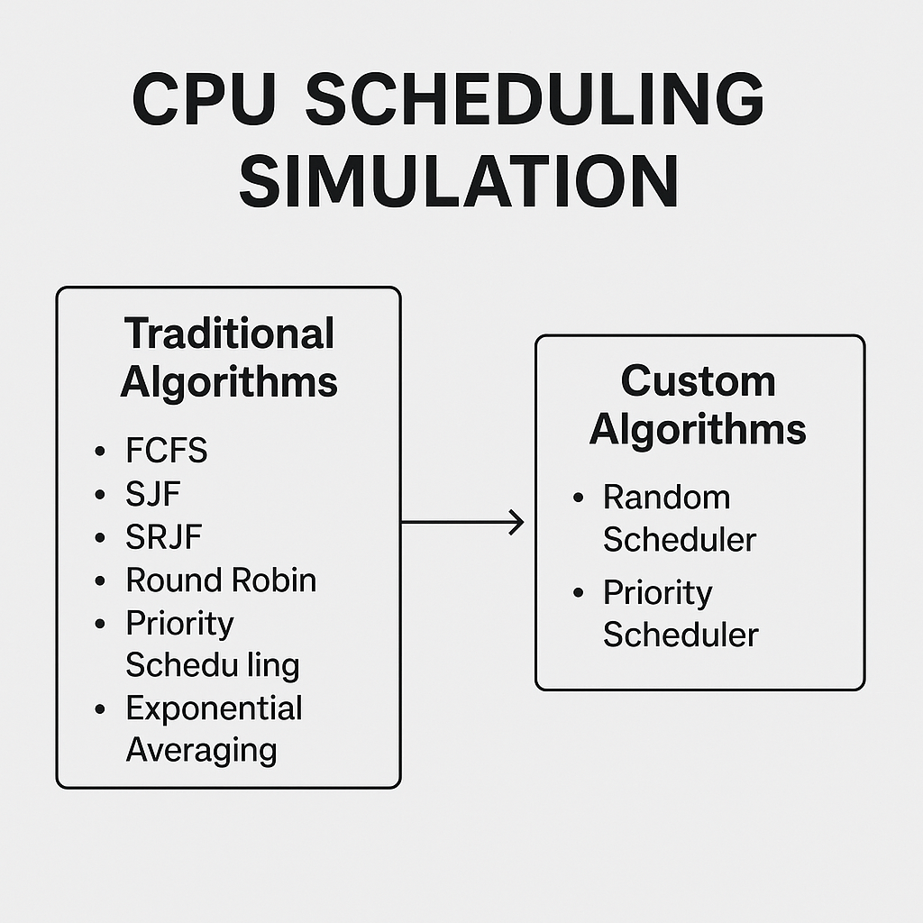
- Objectives

- Implement a working Java-based process scheduling simulator.
- Add two custom algorithms (Random & Priority scheduling).
- Allow dynamic input of process and system parameters.
- Compare all algorithms based on performance metrics.

- System Parameters & User Input

Users are prompted to input:

- Number of Processes: 5

- Context Switch Time: 4

- Degree of Multiprogramming: 3

- Number of CPU/IO bursts: 6

- CPU burst range: 6 to 12

- IO burst range: 5 to 10

- Priority range: 5 to 10

- Arrival time range: 0 to 6

- Initial Tau: 5

- Alpha for exponential averaging: 0.5

- Random generation method: Gaussian (0)

- Implemented Algorithms
4.1 First Come First Served (FCFS)
Processes are executed in the order of arrival.
4.2 Shortest Job First (SJF)
Picks the process with the shortest next CPU burst.
4.3 Shortest Remaining Time First (SRJF)
Preemptive version of SJF, re-evaluates queue after every unit.
4.4 Round Robin (RR)
Each process gets a fixed time quantum in a cyclic order.
4.5 Priority Scheduling
Schedules based on process priority (lower value = higher priority).
4.6 Exponential Averaging
Predicts CPU burst using past behavior with alpha smoothing factor.
4.7 Random Scheduler
Selects a process randomly from the ready queue.
4.8 Dynamic Priority Scheduler
Random priorities are assigned at start and used for scheduling.

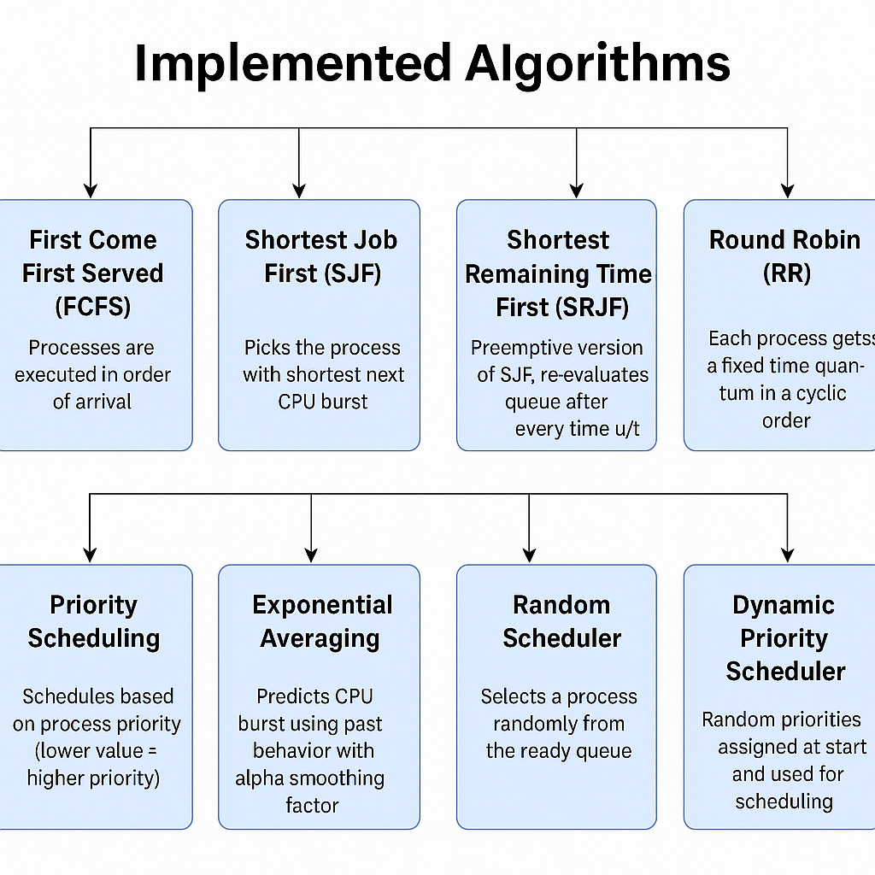

- Results & Comparison

The simulator prints a detailed log for each algorithm execution, including:
- Process execution timeline
- Burst completions
- IO wait transitions
- Process completion and turnaroun

Below is a summary of average performance metrics:

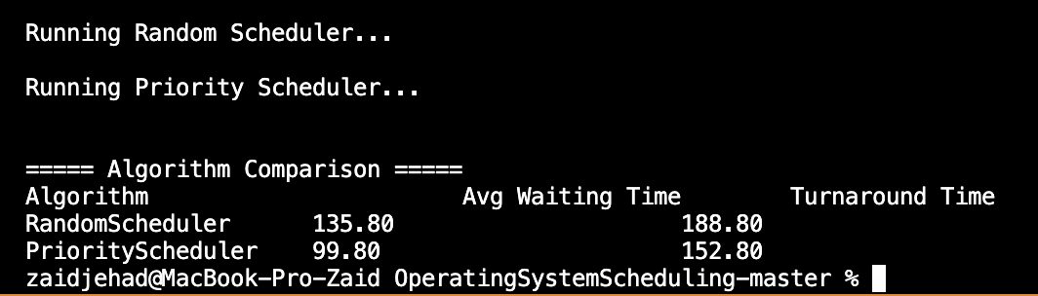

Code:

PriorityScheduler:

import java.util.*;

public class PriorityScheduler {

Queue<Process> jobQueue;
PriorityQueue<Process> readyQueue;
LinkedList<Process> deviceList;
int degreeOfMP;
int contix;
Random random = new Random();

public PriorityScheduler(Queue<Process> jobQueue, LinkedList<Process> deviceList, int degreeOfMP, int contix) {
this.jobQueue = jobQueue;
this.deviceList = deviceList;
this.degreeOfMP = degreeOfMP;
this.contix = contix;
this.readyQueue = new PriorityQueue<>(Comparator.comparingInt(p -> p.priority));
}

public double[] applyPriority() {
int currentTime = 0;
int capacity = degreeOfMP;
Process runningState = null;
int totalWaitingTime = 0;
int totalTurnaroundTime = 0;
int completedProcesses = 0;
List<Process> finished = new ArrayList<>();

while (true) {
while (!jobQueue.isEmpty() && jobQueue.peek().arrivalTime <= currentTime) {
readyQueue.add(jobQueue.poll());
}

for (Process p : readyQueue) {
p.timeInTheSystem++;
p.timeInTheReadyQueue++;
}
for (Process p : deviceList) {
p.timeInTheSystem++;
}
if (runningState != null) {
runningState.timeInTheSystem++;
}

if (runningState == null && !readyQueue.isEmpty()) {
runningState = readyQueue.poll();
}

if (runningState != null) {
runningState.decrementFCFS();
if (runningState.getCurrentBurst().timeNeeded == 0) {
runningState.currentBurst++;
if (runningState.currentBurst >= runningState.content.length) {
finished.add(runningState);
totalWaitingTime += runningState.timeInTheReadyQueue;
totalTurnaroundTime += runningState.timeInTheSystem;
completedProcesses++;
runningState = null;
capacity++;
} else if (!runningState.isCPU()) {
deviceList.add(runningState);
runningState = null;
}
}
}

for (int i = 0; i < deviceList.size(); i++) {
deviceList.get(i).decrementFCFS();
if (deviceList.get(i).getCurrentBurst().timeNeeded == 0) {
Process p = deviceList.remove(i);
p.currentBurst++;
p.arrivalTime = currentTime;
readyQueue.add(p);
i--;
}
}

currentTime++;

if (runningState == null && deviceList.isEmpty() && readyQueue.isEmpty() && jobQueue.isEmpty()) {
break;
}
}

double avgWaiting = (double) totalWaitingTime / completedProcesses;
double avgTurnaround = (double) totalTurnaroundTime / completedProcesses;

return new double[]{avgWaiting, avgTurnaround};
}
}

RandomScheduler :

import java.util.*;

public class RandomScheduler {

Queue<Process> jobQueue;
Queue<Process> readyQueue;
LinkedList<Process> deviceList;
int degreeOfMP;
int contix;
Random random = new Random();

public RandomScheduler(Queue<Process> jobQueue, Queue<Process> readyQueue, LinkedList<Process> deviceList,
int degreeOfMP, int contix) {
this.jobQueue = jobQueue;
this.readyQueue = readyQueue;
this.deviceList = deviceList;
this.degreeOfMP = degreeOfMP;
this.contix = contix;
}

public double[] applyRandom() {
int currentTime = 0;
int capacity = degreeOfMP;
Process runningState = null;
int totalWaitingTime = 0;
int totalTurnaroundTime = 0;
int completedProcesses = 0;
List<Process> finished = new ArrayList<>();

while (true) {
// Move processes from jobQueue to readyQueue
while (!jobQueue.isEmpty() && jobQueue.peek().arrivalTime <= currentTime) {
readyQueue.add(jobQueue.poll());
}

for (Process p : readyQueue) {
p.timeInTheSystem++;
p.timeInTheReadyQueue++;
}
for (Process p : deviceList) {
p.timeInTheSystem++;
}
if (runningState != null) {
runningState.timeInTheSystem++;
}

if (runningState == null && !readyQueue.isEmpty()) {
int index = random.nextInt(readyQueue.size());
runningState = ((LinkedList<Process>) readyQueue).remove(index);
}

if (runningState != null) {
runningState.decrementFCFS();
if (runningState.getCurrentBurst().timeNeeded == 0) {
runningState.currentBurst++;
if (runningState.currentBurst >= runningState.content.length) {
finished.add(runningState);
totalWaitingTime += runningState.timeInTheReadyQueue;
totalTurnaroundTime += runningState.timeInTheSystem;
completedProcesses++;
runningState = null;
capacity++;
} else if (!runningState.isCPU()) {
deviceList.add(runningState);
runningState = null;
}
}
}

for (int i = 0; i < deviceList.size(); i++) {
deviceList.get(i).decrementFCFS();
if (deviceList.get(i).getCurrentBurst().timeNeeded == 0) {
Process p = deviceList.remove(i);
p.currentBurst++;
p.arrivalTime = currentTime;
readyQueue.add(p);
i--;
}
}

currentTime++;

if (runningState == null && deviceList.isEmpty() && readyQueue.isEmpty() && jobQueue.isEmpty()) {
break;
}
}

double avgWaiting = (double) totalWaitingTime / completedProcesses;
double avgTurnaround = (double) totalTurnaroundTime / completedProcesses;

return new double[]{avgWaiting, avgTurnaround};
}
}

- Conclusion

This project provided a hands-on understanding of CPU scheduling. By implementing and comparing different strategies, we gained insights into:

- How process arrival and burst time randomness affects scheduling

- The impact of context switching

- Preemptive vs non-preemptive algorithms

Custom schedulers like Random and Priority-based provided creative insight into alternative scheduling behaviors.

